Scenario: check windowhandles
Step: Launch "framesPage" WebPage - PASS
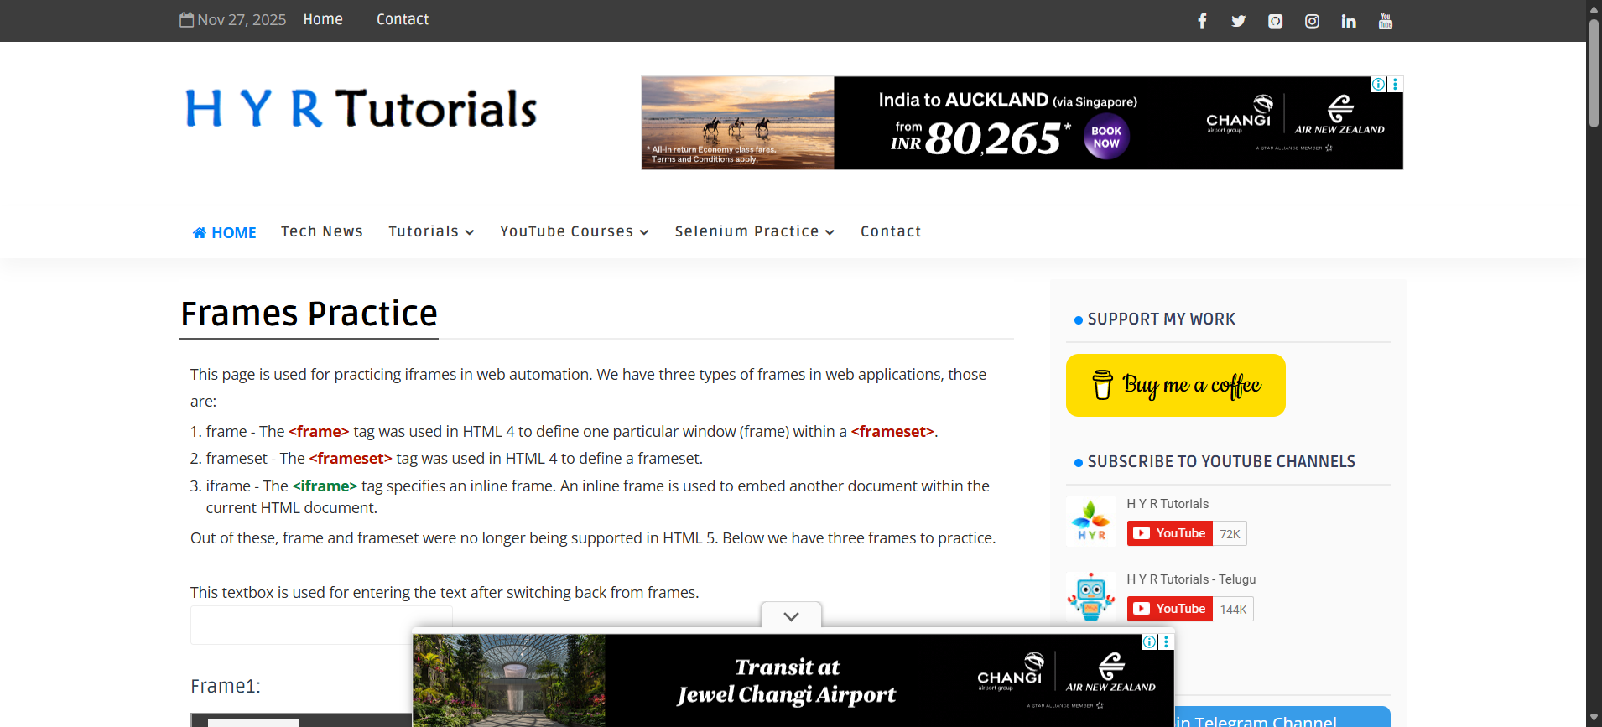
Step: And the user enters "subbu" into the "inputbox" textbox at the "WHPage" page - PASS
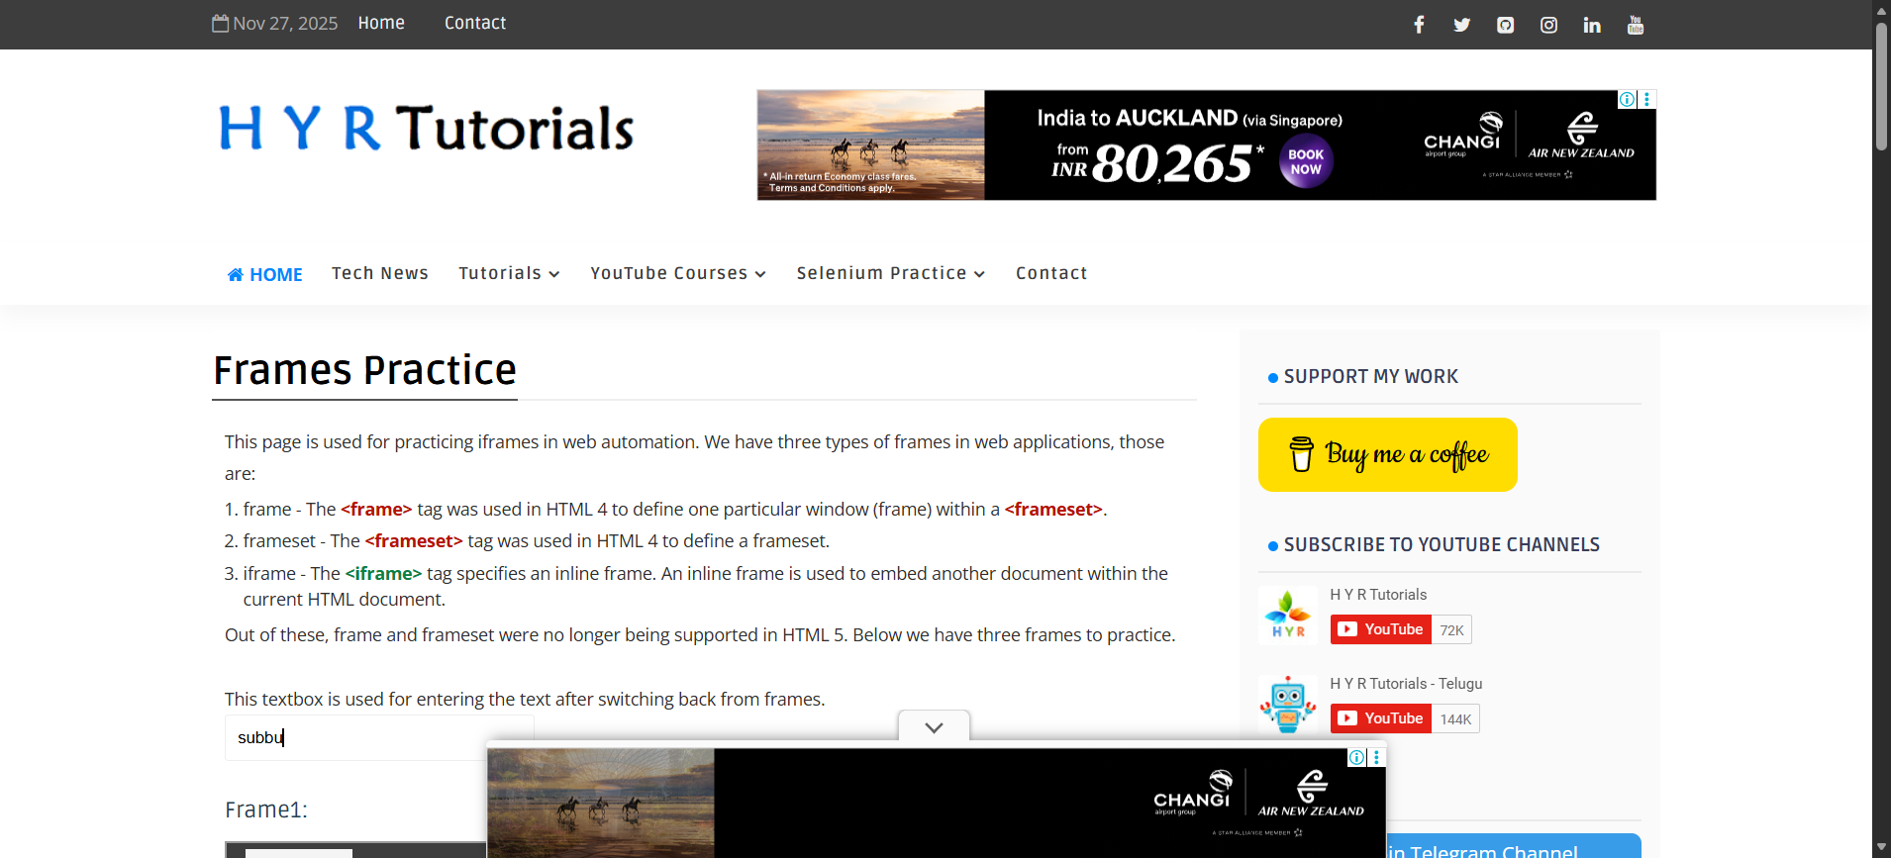
Step: And the user enters "subbu" into the "inputbox" textbox at the "WHPage" page - PASS
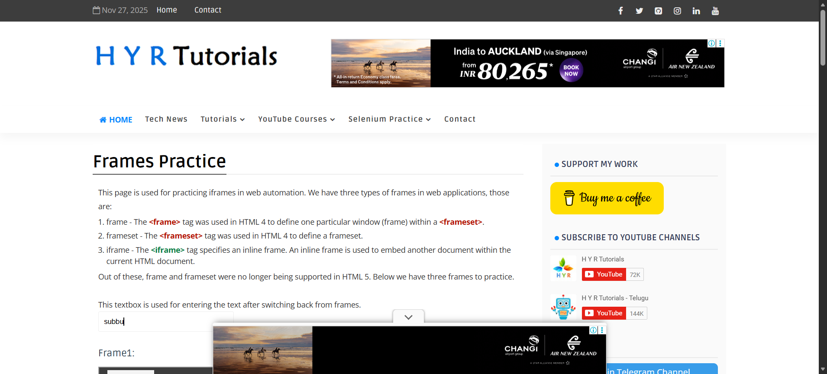
Execution Summary:
Total Steps: 3
Passed: 3
Failed: 0

